CTM-I Use Case

Tier Match

Version 0.1

Use Case Name | Tier Match
Actor | Market Ops, Operations, App Support
Pre-conditions /Assumptions | User has Browser and is aware of the http path to the application.  User has successfully logged into the CTM-I application.  User has the right role to see the menu options.
Post Conditions | None
Screenshot | 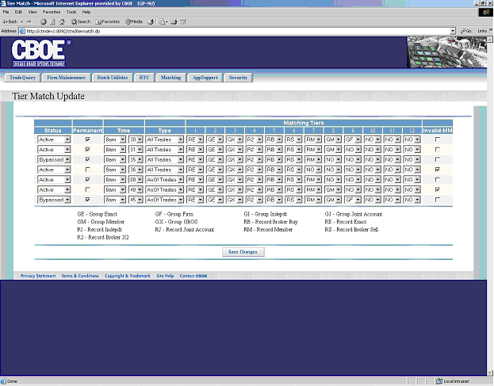
Flow of Events | - User selects “Tier Match” from the menu.  - Requests are sent to CTM-R to retrieve the list of match jobs.  - Tier Match screen is displayed.  - The data is displayed in a table format.  - The table lists all data and does not support paging.  - All fields in the table are editable.  - Status – Selection of “Active” or “Bypassed”  - Permanent (checked = Yes; unchecked = No)  - Time  - Type – Selection of “As Of” and “All”  - Matching Tiers – 12 different tiers offering the selection of the tier and the matching type. The available options are GE, GF, GI, GJ, GM, GX, RB, RE, RI, RJ, RM, RS, and R2.  - Match Invalid Market Maker (checked = Yes; unchecked = No)  - The user presses the “Save Changes” button to save the changes made.  - Changes are sent to CTM-R to process  - Tier Match screen is displayed with the results from CTM-R.
Alternative Path | None

